

For
Southern Regional Load Dispatch Centre (SRLDC) of GRID-INDIA, Bengaluru

AUDIT REPORT
SECURE CODE REVIEW

Document Control
Document type | Secure Code Review Report for Southern Regional Load Dispatch Centre (SRLDC) of GRID-INDIA, Bengaluru.
Document owner | Prime Infoserv Private Limited

Authors & Auditors | Mail ID
Soumyarup Ghosh | soumyarup.ghosh@primeinfoserv.com

Reviewed & verified by | Mail ID
Ankit Mukherjee | ankit@primeinfoserv.com

Revision History
Version | Date | Description
1.0 | 29/01/2026 | Secure Code Review of (Gridopn_code) application for Southern Regional Load Dispatch Centre (SRLDC) of GRID-INDIA, Bengaluru.

Assessment Information - Auditee
Client | Southern Regional Load Dispatch Centre (SRLDC) of GRID-INDIA, Bengaluru.
Contact Person | Mr. Kalikari B Reddy
Contact Number | +91 7036726016 | Mail ID | balreddy@grid-india.in
Assessment Type | Secure Code Review.
PO No. & Date | GEMC-511687758399746 & Dt. 01.03.2024
Report Ref. No. | PIPL/25-26/NLDC Delhi/SCR/Finance/0112122025
Assessment Period (Stage I) | 22/01/2026 – 29/01/2026 | Report Date (Stage I) | 29/01/2026
Notice of Confidentiality:
This document contains proprietary and confidential information of Prime Infoserv Private Limited. The recipient agrees to maintain this information in confidence and not to reproduce or to disclose this information to any person outside of the group directly responsible for the evaluation of its contents. There is no obligation to maintain the confidentiality of any information which was known to the recipient prior to the receipt of this document from Prime Infoserv Private Limited or which becomes publicly known through no fault of the recipient or is received without obligation of confidentiality from a third party owing no obligation of confidentiality to Prime Infoserv Private Limited.

Table of Contents

1. Introduction 4
2. Methodology & Approach 4
2.1. Source Code Review Approach 4
2.2. Project Phases 4
2.3. Source Code Review Methodology 6
2.4. Best Practices 6
2.5. Standards & Framework Followed 7
2.6. Language Specific Tools 7
3. In Scope Application Details 8
4. Disclaimer: 8
5. Assumptions: 8
6. Summary of findings (Finance): 9
7. About us 29
8. Key Customers in the domain 29
9. Audit Test Standard 30
10. Team Skill Set 30
11. Contact Us 31

Introduction
Security code review is the process of auditing the source code for an application to verify that the proper security controls are present, that they work as intended, and that they have been invoked in all the right places. Code review is a way of ensuring that the application has been developed to be “self-defending” in its given environment.
Security code review is a method of assuring secure application developers are following secure development techniques. A general rule of thumb is that a penetration test should not discover any additional application vulnerabilities relating to the developed code after the application has undergone a proper security code review.

Methodology & Approach
Our Source Code review combines Static Analysis Security Testing (SAST) techniques with manual review and testing techniques of the target application, providing a deliverable with both tactical and strategic recommendations to improve the security posture of such target application. These recommendations are both actionable and advisory in nature and are presented to the customer.
The process involves methodical and expert driven testing of the target application to determine if the application is vulnerable to application layer security risks. This level of testing validates the application layer security controls and the security effectiveness of software development and deployment standards by determining how resilient the web application is to determined attackers.

Source Code Review Approach
- Source Code Review is performed by two teams. One team performs the automated scans and the other performs the manual review of the code
- Both teams perform the tasks simultaneously and findings are consolidated in a detailed draft report
- The findings are tested and verified again to rule our false positives and to have a clear understanding of the vulnerabilities
- An executive summary is prepared with the findings with detailed explanation
- Solutions for the identified findings are embedded in the report for remediation
- Based on the agreement our team shall also assist in the fixing / remediation of the findings

Project Phases
- Pre-Review Discovery
A representative from the target application’s development team is asked to confirm the scope of the engagement. We require a full list of the applications to be tested, design documentation, and third-party in-use, applications, and libraries used during the design, coding, and testing of the target application.
- Documentation Review
We conduct a detailed review of the existing documentation for each application listed in this proposal, including design documents, concept of operations, and source code listings.

- Architecture and Product Familiarization
We review the overall architecture of the application to become familiar with the security issues resulting from any third-party tools, applications, libraries, or services being used. This includes interface specifications for any pre-existing libraries or utilities, as well as security vulnerabilities or known issues with commercial tools and applications.
- Static and Manual Source Code Analysis
We perform a detailed, manual analysis of the application source code. Many of the vulnerabilities discovered in a source code review are similar to vulnerabilities discovered during an Application Penetration Test. Unlike a penetration test, a code review allows for a greater breadth of coverage and an increased confidence level in the results of the assessment. This is principally a result of having a fuller understanding of the design, software architecture and its internals, allowing identified vulnerabilities to have their exploitability fully assessed from a risk perspective. Some vulnerabilities or design flaws are also far easier to discover in a code review, such as “hidden” functionality in an application, or deficiencies in auditing controls.
The following table lists some of the different vulnerability classes we cover during an Application Source Code Review.

Vulnerability | Items Tested
Access Control | - Inconsistent use of centralized authentication and authorization controls Unlimited Login Attempts  - Password Complexity Policy  - Single-sign on integration  - Inadequate Auditing Controls
Session Management | - Weak Session Identifier Generation  - Session Replay  - Session Fixation  - Insufficient Session Expiration
Data Validation | - Improper Input Validation  - Dynamic SQL Commands  - Improper Output Encoding  - Format Strings
Application Resource Handling | - Path Traversal  - Predictable Object Identifiers  - XML Entity Expansion  - Local & Remote File Inclusion  - Shell command execution
Cryptography | - Weak Algorithms  - Poor Key Management  - Insecure Data Storage
Logical Attacks | - Abuse of Functionality  - Workflow Bypass
“Hidden” Functionality | - Backdoors  - Debugging Interfaces  - Undocumented Inputs
Code Quality | - Verbose Error Messages  - Unused / Dead Code  - Improper Exception / Error Handling  - Inconsistent Logging

Source Code Review Methodology

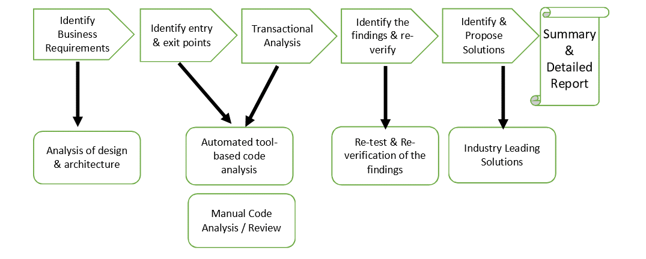

Best Practices

Understand the developers' approach. Before starting a secure code review, talk to the developers and understand their approaches to mechanisms like authentication and data validation. Information gathered during this discussion can help jump-start the review and significantly decrease the time a reviewer spends trying to understand the code.

Use multiple techniques. If possible, use both manual and automated techniques for the review because each method will find things that the other doesn't. In addition, try to use more than one automated tool because the strengths of each differ and complement the others.

Do not assess level of risk. A secure code review should not attempt to make judgments about what is acceptable risk. The review team should report what it finds. The customer uses the program's approved risk assessment plan to assess risk and decide whether to accept it or not.

Focus on the big picture. When performing a manual review, resist trying to understand the details of every line of code. Instead, gain an understanding of what the code as a whole is doing and then focus the review on important areas, such as functions that handle login or interactions with a database. Leverage automated tools to get details on specific flaws.

Follow up on review points. After a review, hold a follow-up discussion with the development team to help them understand what the findings mean and how to address them.

Stick to the intent of the review. Secure code review is not penetration testing. Review teams should not be allowed to "pen-test" a running version of the code because it can bias the results by giving a false sense of completeness.

Standards & Framework Followed

- Open Web Application Security Project Framework (OWASP)
- OWASP Code Review Guide
- Web Application Security Consortium (WASC)

Language Specific Tools

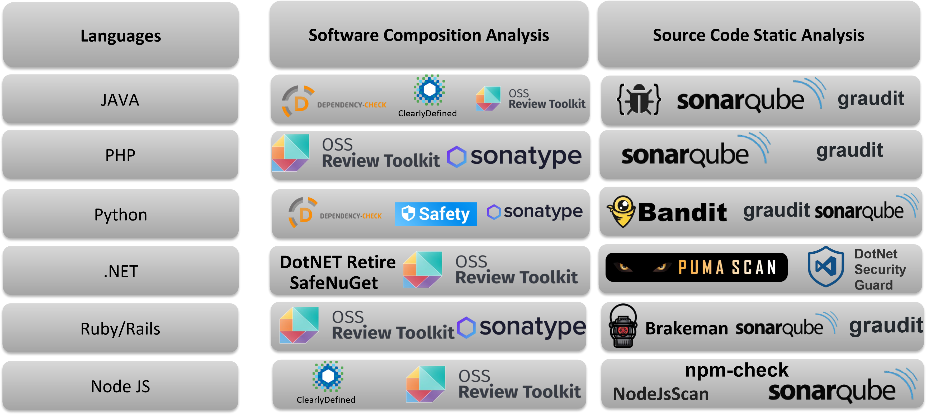


In Scope Application Details

Sl. No. | Brief Specification of Application | Language
1 | Gridopn_code | Python, TypeScript, JavaScript

Disclaimer:
This report is intended to provide a detailed overview of the completed Secure Code Review for Southern Regional Load Dispatch Centre, Bengaluru, during the assessment period which describes the latest findings identified by Prime Infoserv Private Limited.

Assumptions:
This report has been produced based on the output of the Security Assessment that was conducted on a particular duration. All vulnerabilities have been highlighted in the report assuming that the utilities and other applications installed on the systems were being used for the business purpose, and accordingly the recommendation to mitigate those vulnerabilities have been made. It is, therefore, recommended that prior to acting on the recommendation, following actions are taken:
- Ascertain whether a service or application for which vulnerability has been identified and recommendation is made is actually required in the system for business purpose. In case there is no requirement of such services or applications, the same may be removed or disabled following an appropriate process. Else, the recommendations are applied on the system.
- Appropriate backup and rollback plan to be made prior to implementing the recommendation on the system.
- Vulnerabilities identified were as on the date testing conducted and also as per the scan policies (intrusive or non-intrusive) & plugins selected. Also, the vulnerabilities identified after the scan date may also not form part of this report.
- Informing Vulnerabilities identified to Computer Emergency Response Team (CERT-In) as pre-directives.

Summary of findings (Gridopn_code):

Sl. No. | Vulnerability Name | Vulnerability Risk Type
1 | SQL Injection | High
2 | Path Traversal | High
3 | Hardcoded Credentials | High
4 | Remote Code Execution | High
5 | Parameter Tampering (IDOR) | High
6 | CSRF | Medium
7 | SSRF | Medium
8 | Client DOM XSS | Medium

- Detail Findings:

- Vulnerability Name: SQL Injection
Vulnerability Rating: High
Vulnerability Description:
The application constructs SQL queries using unsafe string formatting (Python .format() or f-strings) with user-controlled input. This allows an attacker to inject malicious SQL commands to bypass authentication, access unauthorized data, or modify/delete the database content.
Affected Line(s):
Object | File | Line(s)
cursor.execute | Backend/dFBackend.py | 703, 708, 737, 742, 796, 800, 827, 1017, 3189, 3193, 3222, 3580, 3632, 3636, 3639, 4381, 5177
Recommendation:
Currently, the code mixes data and commands together using .format(), which is what allows the "Injection". You need to separate them so the database treats the input strictly as data, never as executable instructions.How to Apply the Fix
- Replace Placeholders: Change {0}, {1}, or f-strings to %s.
- Pass Data Separately: Pass the variables as a second argument (a tuple) to cursor.execute().
Example:
- BAD: cursor.execute("SELECT * FROM table WHERE id = {0}".format(user_id))
- GOOD: cursor.execute("SELECT * FROM table WHERE id = %s", (user_id,))
Source Code Examples:
Python
Vulnerable Code:
# Backend/dFBackend.py
cursor.execute("select ... where state_id = {0}".format(state))
Secure Code (Recommended):
# Use placeholders (%s)
cursor.execute("SELECT ... WHERE state_id = %s", (state,))

- Vulnerability Name: Path Traversal
Vulnerability Rating: High
Vulnerability Description:
The application allows a user to download files by specifying the file path directly in the API request parameter (downloadLink). The server does not validate if this path is within the intended directory. An attacker can manipulate this parameter (e.g., using ../../) to traverse the file system and download arbitrary files from the server, such as source code, configuration files containing passwords, or system files.
Affected Line(s):
Object | File | Line(s)
file_path = download_link (Input Assignment) | Backend/dFBackend.py | 8478
send_file(file_path, ...) (Execution) | Backend/dFBackend.py | 8487
Recommendation:
- Validate Input: Ensure the requested filename contains only allowed characters (alphanumeric).
- Use ID Maps: Instead of sending the path, send an ID that maps to a path on the server side.
- Sanitize Path: Use werkzeug.utils.secure_filename to strip directory components.
- Enforce Safe Directory: Use send_from_directory with a hardcoded directory argument to ensure files can only be served from a specific folder.
Source Code Examples:
Python
Vulnerable Code:
# Backend/dFBackend.py
@app.route('/api/downloadlineflows', methods=['POST'])
def downloadLineFlows():
# ...
download_link = request.json.get('downloadLink')
# ...
file_path = download_link # <--- User input directly assigned
# ...
return send_file(file_path, as_attachment=True, ...) # <--- Arbitrary file read
Secure Code (Recommended):
from werkzeug.utils import secure_filename
import os
@app.route('/api/downloadlineflows', methods=['POST'])
def downloadLineFlows():
# ...
download_link = request.json.get('downloadLink')
# 1. Extract just the filename (removes ../ and paths)
filename = secure_filename(os.path.basename(download_link))
# 2. define the safe directory
safe_dir = os.path.join(shared_drive_path, "Lineflows Report work")
# 3. Serve safely
return send_from_directory(safe_dir, filename, as_attachment=True)

- Vulnerability Name: Hardcoded Credentials
Vulnerability Rating: High
Vulnerability Description:
The application stores sensitive database credentials (username prasadbabu and password BabuPrasad#123) in plain text directly within the source code. This allows any attacker who gains access to the source code (e.g., via the Path Traversal vulnerability also present in this app) to immediately compromise the entire database.
Affected Line(s):
Object | File | Line(s)
password='BabuPrasad#123' | Backend/configBackend.py | 147, 156
password='BabuPrasad#123' | Backend/dFBackend.py | 1180, 4367, 5157, 7621, 7735, 8066
Recommendation:
- Remove Secrets from Code: Never commit passwords, API keys, or secrets to the source code.
- Use Environment Variables: Store secrets in environment variables (e.g., .env file) which are loaded at runtime.
- Use a Secrets Manager: For enterprise deployments, use a dedicated secrets management vault (like AWS Secrets Manager or HashiCorp Vault).
Source Code Examples:
Python
Vulnerable Code:
# Backend/dFBackend.py
conn = psycopg2.connect(
database="demand_forecast_states",
user='prasadbabu',
password='BabuPrasad#123', # <--- Plaintext credential
host='10.0.100.79'
)

Secure Code (Recommended):
import os
# Backend/dFBackend.py
conn = psycopg2.connect(
database=os.getenv("DB_NAME"),
user=os.getenv("DB_USER"),
password=os.getenv("DB_PASSWORD"), # <--- Loaded from environment
host=os.getenv("DB_HOST")
)

- Vulnerability Name: Remote Code Execution
Vulnerability Rating: High
Vulnerability Description:
The application uses Python's eval() function to dynamically execute formula strings stored in the database. The calculate_formula function (line 291-298) takes a formula, replaces placeholders with data values, and then executes the resulting string as Python code using eval(). If an attacker can manipulate the formula data in the database (e.g., via the SQL Injection vulnerability), they can inject arbitrary Python code that will be executed on the server, leading to complete system compromise.
Affected Line(s):
Object | File | Line(s)
eval(formula) | Backend/dFBackend.py | 295
Recommendation:
- Remove eval(): Never use eval() or exec() on untrusted input.
- Use Safe Expression Evaluators: If you need to evaluate mathematical formulas, use a safe library like ast.literal_eval() (for literals only) or numexpr / simpleeval (for mathematical expressions).
- Whitelist Operations: If dynamic formulas are required, parse and validate them using an Abstract Syntax Tree (AST) to ensure only safe operations are allowed.
Source Code Examples:
Python
Vulnerable Code :
# Backend/dFBackend.py (Line 291-295)
def calculate_formula(row, short_locations, formula):
try:
for loc in short_locations:
formula = formula.replace(loc, str(row[loc]))
return eval(formula) # <--- Arbitrary code execution
except Exception as e:
return '--'

Secure Code (Recommended):
# Option 1: Use a safe expression evaluator
from simpleeval import simple_eval
def calculate_formula(row, short_locations, formula):
try:
# Build a safe namespace with only the needed variables
names = {loc: row[loc] for loc in short_locations}
return simple_eval(formula, names=names) # <--- Safe evaluation
except Exception as e:
return '--'
# Option 2: If only basic math is needed, use ast.literal_eval or numexpr
import numexpr as ne
def calculate_formula(row, short_locations, formula):
try:
for loc in short_locations:
formula = formula.replace(loc, str(row[loc]))
return ne.evaluate(formula) # <--- Safer than eval
except Exception as e:
return '--'

- Vulnerability Name: Parameter Tampering (IDOR)
Vulnerability Rating: High
Vulnerability Description:
The application accepts a state_id parameter from the client in API requests (e.g., /api/fetchrevisions) and uses it directly to query the database without verifying that the authenticated user is authorized to access data for that particular state. This allows an attacker to manipulate the state parameter in the request to access data belonging to other states, leading to unauthorized data disclosure.
Affected Line(s):
Object | File | Line(s)
state = params["state"] (Parameter Assignment) | Backend/dFBackend.py | 702, 736, 795, 878, 3188, 3631
Recommendation:
- Implement Authorization Checks: After authentication, verify that the user's session/role is authorized to access the requested state_id.
- Use Session-Based State Filtering: For non-admin users, retrieve the allowed state_id from the user's session/JWT token instead of accepting it from the request.
- Enforce RBAC: Implement Role-Based Access Control to ensure users can only access their own state's data unless they have admin privileges.
Vulnerable Endpoints:
- /api/fetchrevisions
- /api/fetchintradayrevisions
- /api/fetchweekrevisions
- /api/fetchmonthrevisions
- /api/fetchyearrevisions etc. Multiple other data retrieval endpoints
Source Code Examples:
Python
Vulnerable Code:
# Backend/dFBackend.py (e.g., fetchRevisions endpoint)
@app.route('/api/fetchrevisions', methods=['POST'])
@jwt_required(locations=["cookies"])
@token_required
def fetchRevisions():
try:
conn = psycopg2.connect(**db_params)
cursor = conn.cursor()
params = request.get_json()
state = params["state"] # <--- User-controlled, no authorization check
cursor.execute("select ... where state_id = {0}...".format(state))
# Returns data for ANY state the user requests

Secure Code (Recommended):
# Backend/dFBackend.py (Secure version)
@app.route('/api/fetchrevisions', methods=['POST'])
@jwt_required(locations=["cookies"])
@token_required
def fetchRevisions():
try:
jwt_data = get_jwt()
user_role = jwt_data.get("role")
username = jwt_data.get("sub")
conn = psycopg2.connect(**db_params)
cursor = conn.cursor()
params = request.get_json()
requested_state = params["state"]
# Authorization check: Non-admin users can only access their own state
if user_role != "admin":
cursor.execute("SELECT state_id FROM states WHERE username = %s", (username,))
allowed_state = cursor.fetchone()
if not allowed_state or str(requested_state) != str(allowed_state[0]):
return jsonify(status="failure", message="Unauthorized access"), 403
# Proceed with query only if authorized
cursor.execute("SELECT ... WHERE state_id = %s", (requested_state,))
# ...

- Vulnerability Name: CSRF
Vulnerability Rating: Medium
Vulnerability Description:
The application does not implement CSRF protection tokens for state-changing operations (POST, PUT, DELETE requests). This allows an attacker to craft a malicious website or email that, when visited by an authenticated user, can trigger unauthorized actions on the application (such as uploading files, modifying data, or deleting records) without the user's knowledge or consent.
Affected Line(s):
Object | File | Line(s)
Flask app configuration (Missing CSRF Protection) | Backend/dFBackend.py | Application-wide (No CSRFProtect implementation)
Recommendation:
- Implement CSRF Tokens: Use Flask-WTF's CSRFProtect extension to automatically generate and validate CSRF tokens for all state-changing requests.
- Validate Tokens: Ensure that every POST/PUT/DELETE request includes a valid CSRF token that matches the user's session.
- Use SameSite Cookies: Set the SameSite attribute on session cookies to Strict or Lax to provide additional protection against CSRF attacks.
Vulnerable Endpoints (Examples):
- /api/uploaddayahead (POST)
- /api/uploadintradaydata (POST)
- /api/uploadweekahead (POST)
- /api/uploadmonthahead (POST)
- All other POST/PUT/DELETE endpoints
Source Code Examples:
Python
Vulnerable Code:
# Backend/dFBackend.py
from flask import Flask, request, jsonify
from flask_jwt_extended import JWTManager
app = Flask(__name__)
jwt = JWTManager(app)
# No CSRF protection implemented
@app.route('/api/uploaddayahead', methods=['POST'])
@jwt_required(locations=["cookies"])
def upload_dayahead_data():
# Accepts POST request without CSRF token validation
# An attacker can forge this request from another site
data = request.form.get('data')
# ... process upload

Secure Code (Recommended):
# Backend/dFBackend.py
from flask import Flask, request, jsonify
from flask_jwt_extended import JWTManager
from flask_wtf.csrf import CSRFProtect
app = Flask(__name__)
jwt = JWTManager(app)
# Enable CSRF protection
csrf = CSRFProtect(app)
# Configure session cookie security
app.config['SESSION_COOKIE_SAMESITE'] = 'Lax'
app.config['SESSION_COOKIE_HTTPONLY'] = True
app.config['SESSION_COOKIE_SECURE'] = True # Requires HTTPS
@app.route('/api/uploaddayahead', methods=['POST'])
@jwt_required(locations=["cookies"])
def upload_dayahead_data():
# CSRF token is automatically validated by CSRFProtect
# Requests without valid token will be rejected
data = request.form.get('data')
# ... process upload

Frontend Implementation:
// Include CSRF token in requests
fetch('/api/uploaddayahead', {
method: 'POST',
headers: {
'X-CSRFToken': getCsrfToken() // Get token from meta tag or cookie
},
body: formData
});

- Vulnerability Name: SSRF
Vulnerability Rating: Medium
Vulnerability Description:
The application uses the requests library to make HTTP requests to external URLs that may be influenced by user input or database content. If an attacker can control or manipulate these URLs (e.g., through SQL Injection or parameter tampering), they can force the server to make requests to internal network resources, cloud metadata endpoints (like AWS EC2 metadata at 169.254.169.254), or other unintended destinations. This can lead to information disclosure, port scanning of internal networks, or access to sensitive cloud credentials.
Affected Line(s):
Object | File | Line(s)
requests.get(...) | Backend/dFBackend.py | 2500
Recommendation:
- Validate URLs: Implement a whitelist of allowed domains/hosts that the application is permitted to connect to.
- Block Private IP Ranges: Reject requests to private IP addresses (10.0.0.0/8, 172.16.0.0/12, 192.168.0.0/16, 127.0.0.0/8) and cloud metadata endpoints (169.254.169.254).
- Use URL Parsing: Parse and validate the URL scheme, hostname, and port before making the request.
- Disable Redirects: Set allow_redirects=False to prevent attackers from bypassing URL validation through redirects.
Source Code Examples:
Python
Vulnerable Code:
# Backend/dFBackend.py (Line ~2500)
@app.route('/api/submittimingentries', methods=['POST'])
def submitTimingEntries():
try:
# ...
for i in timing_entries:
# URL constructed from database/user data
response = requests.get(
"https://oms2.srldc.in/Codebook/EnterConstituentTime?codeId={0}&enteredTime={1}".format(
i["codeId"], i["codeIssueTime"]
)
)
# No validation of URL or parameters

Secure Code (Recommended):
from urllib.parse import urlparse
ALLOWED_HOSTS = ['oms2.srldc.in']
def is_safe_url(url):
parsed = urlparse(url)
return parsed.hostname in ALLOWED_HOSTS
# Before making request:
url = "https://oms2.srldc.in/...".format(...)
if not is_safe_url(url):
return jsonify(status="failure", message="Invalid URL"), 400
response = requests.get(url, allow_redirects=False, timeout=5)

- Vulnerability Name: Client DOM XSS
Vulnerability Rating: Medium
Vulnerability Description:
The frontend application uses innerHTML to dynamically insert content into the DOM. If this content comes from untrusted sources (such as API responses that could be compromised via SQL Injection or other backend vulnerabilities), an attacker can inject malicious JavaScript code that will execute in the victim's browser, leading to session hijacking, credential theft, or defacement.This vulnerability is contingent on the backend data being compromised. If an attacker successfully exploits SQL Injection to modify database content, that malicious content will be rendered unsafely in the browser.
Affected Line(s):
Object | File | Line(s)
.innerHTML = | Frontend/*.js | Multiple locations (Frontend JavaScript files)
Recommendation:
- Use Safe DOM Methods: Replace innerHTML with safer alternatives like textContent or innerText for plain text.
- Sanitize HTML: If HTML rendering is required, use a trusted sanitization library like DOMPurify.
- Content Security Policy (CSP): Implement a strict CSP header to prevent inline script execution.
- Framework Features: Use Angular's built-in sanitization (which is enabled by default for property binding).
Source Code Examples:
Python
Vulnerable Code:
// Frontend JavaScript
element.innerHTML = apiResponse.data; // <--- Unsafe if data contains <script>

Secure Code (Recommended):
// Option 1: Use textContent for plain text
element.textContent = apiResponse.data; // Safe - renders as text, not HTML
// Option 2: Use DOMPurify for HTML content
import DOMPurify from 'dompurify';
element.innerHTML = DOMPurify.sanitize(apiResponse.data); // Safe - removes scripts
// Option 3: In Angular templates, use property binding (auto-sanitized)
// Template: <div [innerHTML]="trustedHtml"></div>
// Component: this.trustedHtml = this.sanitizer.sanitize(SecurityContext.HTML, data);

About Us



Key Customers in the domain



Audit Test Standard

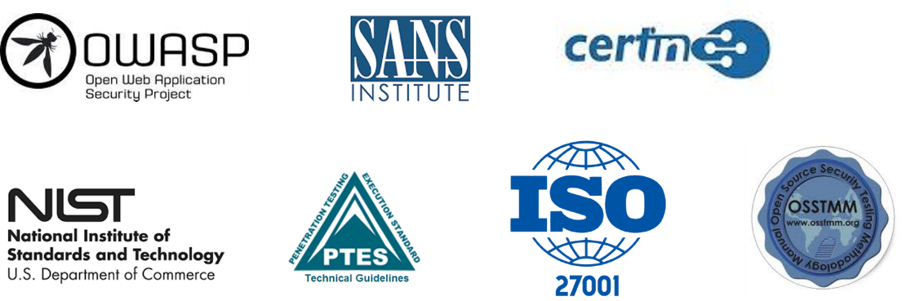

Team Skill Set



Contact Us

Office Contacts | Phone : +91 33 4008 5677  Email : support@primeinfoserv.com; info@primeinfoserv.com
1st Level | Soumyadeep Ghosh  Phone : +91 75839 16075 | Email : soumyadeep@primeinfoserv.com
2nd Level | Shampa Sengupta  Phone : +91 99036 87873 | Email : shampa@primeinfoserv.com

Unlock the Values of
NextGen Solution & Services

Accelerate your digital transformation
journey with us.



